

by

Abhimanyu Singh Bisht

*Date: October 30, 2019*

# Scope

Develop and maintain database system that serves as the backend of a simple EMR system that captures a small portion of relevant information of student clinic of UNCC university. Gather information which is digitally equivalent to paper records. Utilizing the gathered data for the treatment provided and maintaining medical history about the patient.

# Requirements Specification

The purpose of the Electronic Medical Records (EMRs) database is the systematized collection of patient health information and provider information in a digital format that can be created, gathered, managed, and consulted by authorized clinicians. By using this system, the outcome will be more predictable, the process will be more efficient, and the overall healthcare system will be more effective.

The project focuses on student clinic in university, creating a database which is capturing and managing information of students over a period of 3 years and services provided to patients.

This document provides functional and non-functional usage of tables, considerations and requirements listed. The Database Design is composed of definitions for database objects derived by mapping entities to tables, attributes to columns, unique identifiers to unique(primary) keys and relationships to foreign keys. The health information systems easily enable constraints to be placed upon end users' access to particular patient information.

The student clinic of UNCC university is capturing patient demographic information, provider information including their specialization, visit information including time and facility used, clinical care information including the sign & symptoms with prescription and test suggested and billing information consist of information of supplies given to patients.

# Database Design and Requirements

|  |  |  |
| --- | --- | --- |
| **Use case ID** | **Use case description** | **Priority** |
| 1 | Creating a new database emr_db5 | High |
| 2 | Create patient_information table and all the patient information are kept in Patient_information table | Medium |
| 3 | Create zip_code table | Medium |
| 4 | Create provider_information table and all the provider information is kept in this table | Medium |
| 5 | Create visit_information table | Medium |
| 6 | Create clinical_care_information table | Medium |
| 7 | Create billing table | Medium |
| 8 | Create medicine table | Medium |
| 9 | Editing of existing record:  *Change or update the Address of the patient using update command from patient_information table  * Update insurance details of patient using update command from patient_information table | Medium |
| 10 | Searching of particular record:  Using where condition user can search for a item to get displayed | Medium |

**Create Database and Tables**

-- create the database

DROP DATABASE IF EXISTS EMR_DB5; CREATE DATABASE EMR_DB5;

-- select the database USE EMR_DB5;

-- create the tables

CREATE TABLE `patient_information` (

`patient_id` int(11) PRIMARY KEY UNIQUE NOT NULL,

`patient_first_name` varchar(50) NOT NULL,

`patient_last_name` varchar(50) NOT NULL,

`patient_age` int(11) NOT NULL,

`patient_gender` varchar(50) DEFAULT NULL,

`patient_address` varchar(50) DEFAULT NULL,

`patient_zip_code` varchar(20) NOT NULL,

`patient_phone` varchar(50) DEFAULT NULL,

`patient_insurance` varchar(50) DEFAULT NULL

);

CREATE TABLE `zip_code` (

`patient_zip_code` varchar(20) NOT NULL,

`patient_city` varchar(50) NOT NULL,

`patient_state` char(2) NOT NULL

);

CREATE TABLE `provider_information` (

`specialist_id` varchar(50) PRIMARY KEY UNIQUE NOT NULL,

`specialist_name` varchar(50) NOT NULL,

`specialisation` varchar(50) DEFAULT NULL,

`contact_number` varchar(50) DEFAULT NULL,

`availability` varchar(50) DEFAULT NULL,

`open_time` time DEFAULT NULL,

`close_time` time DEFAULT NULL,

`specialist_fees` decimal(10,2) NOT NULL

);

CREATE TABLE `visit_information` (

`appointment_id` int(11) PRIMARY KEY NOT NULL,

`patient_id` int(11) NOT NULL,

`specialist_id` varchar(50) NOT NULL,

`appointment_time_date` datetime NOT NULL,

CONSTRAINT `visit_information_fk_patient_information` FOREIGN KEY (`patient_id`)

REFERENCES `patient_information` (`patient_id`),

CONSTRAINT `visit_information_fk_provider_information` FOREIGN KEY (`specialist_id`)

REFERENCES `provider_information` (`specialist_id`)

);

CREATE TABLE `clinical_care_information` (

`prescription_id` int(11) PRIMARY KEY NOT NULL,

`patient_id` int(11) NOT NULL,

`specialist_id` varchar(50) NOT NULL,

`appointment_id` int(11) NOT NULL,

`symptoms` varchar(100) NOT NULL,

`test` varchar(50) DEFAULT NULL,

`test_fees` decimal(10,2) DEFAULT NULL,

CONSTRAINT `clinical_care_information_fk_patient_information` FOREIGN KEY (`patient_id`)

REFERENCES `patient_information` (`patient_id`),

CONSTRAINT `clinical_care_information_fk_provider_information` FOREIGN KEY (`specialist_id`)

REFERENCES `provider_information` (`specialist_id`),

CONSTRAINT `clinical_care_information_fk_visit_information` FOREIGN KEY (`appointment_id`)

REFERENCES `visit_information` (`appointment_id`)

);

CREATE TABLE `billing` (

`billing_id` int(11) PRIMARY KEY NOT NULL AUTO_INCREMENT,

`patient_id` int(11) NOT NULL,

`prescription_id` int(11) DEFAULT NULL,

`medicine_name` varchar(50) DEFAULT NULL,

`medicine_quantity` int(11) DEFAULT NULL,

CONSTRAINT `billing_fk_clinical_care_information` FOREIGN KEY (`prescription_id`)

REFERENCES `clinical_care_information` (`prescription_id`),

CONSTRAINT `billing_fk_patient_information` FOREIGN KEY (`patient_id`)

REFERENCES `patient_information` (`patient_id`)

);

CREATE TABLE `medicine` (

`medicine_name` varchar(50) DEFAULT NULL,

`medicine_price_USD` decimal(10,2) DEFAULT NULL

);

# Inserting Data to the Tables

-- insert rows into the tables

INSERT INTO patient_information VALUES

(1,'Anushka','Sharma','29','Female','University Terrace Drive','26282','(800) 555-1205','Y'),

(2,'Smith','Jordan','23','Male','Vinca Circle','26282','(980) 551-1605','Y'),

(3,'Sakshi','Shukla','29','Female','Baletine','26299','(480) 235-1209','Y'),

(4,'Virat','Kohli','25','Male','BC Street','21250','(347) 555-1205','Y'),

(5,'Kapil','Dev','30','Male','83 Street','26257','(678) 363-6565','Y'),

(6,'Alex','Fernandes','22','Male','Zukerberg palace','26252','(274) 961-1205','N'),

(7,'Kivela','Paula','22','Female','Berkley','26299','(980) 123-4567','Y'),

(8,'Abhimanyu','Basu','21','Male','K Circle','26250','(560) 656-3355','N'),

(9,'David','Walmore','23','Male','University Terrace North','26282','(632) 654-6598','Y'),

(10,'Tom','Anderson','23','Male','Haven Creek','26250','(491) 325-0103','Y'),

(11,'Anusha','Anderson','27','Female','Uptown Avenue','26257','(230) 540-6310','Y'),

(12,'Albert','Park','26','Male','Woodside','26252','(595) 635-6305','Y'),

(13,'Davis','Wilson','19','Male','Mallard Creek','26250','(496) 555-1205','Y'),

(14,'Robert','Wilk','21','Male','The Edge','26282','(860) 630-1205','N'),

(15,'Tom','Cruise','21','Male','Havelock Society','26211','(800) 555-1205','Y'),

(16,'Sharukh', 'Khan','20','Male','Badshah Green','2','(300) 159-6789','Y'),

(17,'Michelle','Johnson','26','Female','Wall Street','21250','(656) 652-2424','Y'),

(18,'Moumita','Das','24','Female','Jamaican Avenue','26211','(620) 978-3214','Y'),

(19,'Jasmine','Brown','24','Female','Ashford','26252','(656) 985-6541','Y'),

(20,'Deepika','Padukone','24','Female','Singh House','26299','(326) 951-5050','Y');

INSERT INTO zip_code VALUES (26282,'Charlotte','NC'),

(26257,'Charlotte','NC'),

(26252,'Raleigh','NC'),

(21250,'Detroit','MI'),

(26299,'Atlanta','GA'),

(26250,'San Jose','CA'),

(26257,'Atlanta','GA'),

(26211,'Detroit','MI');

INSERT INTO provider_information VALUES

('A101','Dr. Dan Mcpherson','General Physician','(800) 555-1205','Mon-Fri',"08:00:00","17:00:00",20.49),

('A103','Dr. John Evan','General Physician','(980) 355-1205','Mon-Thu',"10:00:00","16:00:00",30.99),

('A105','Dr. Meera Sridhar','General Physician','(807) 555-1277','Sat-Sun',"09:00:00","18:00:00",35.10),

('A107','Dr. Rob Black','Dermatologist','(800) 555-3598','Mon-Fri',"08:00:00","17:00:00",29.99),

('A109','Dr. Rhonda Gentry','Cardiologist','(800) 335-1285','Mon-Wed',"10:00:00","18:00:00",39.99),

('A111','Dr. Lauren Tan','Gynaecology','(800) 555-5963','Mon-Sat',"09:00:00","17:00:00",18.99),

('A115','Dr. Navin Rajwar','Eye Specialist','(800) 335-1969','Mon-Fri',"08:00:00","16:00:00",20.49);

INSERT INTO visit_information VALUES (1, 1, 'A101', '2018-01-21 10:00:00'),

(2, 2, 'A101', '2018-01-21 10:20:00'),

(3, 3, 'A103', '2018-01-21 11:30:00'),

(4, 4, 'A107', '2018-02-21 11:30:00'),

(5, 5, 'A105', '2018-03-21 11:00:00'),

(6, 6, 'A107', '2018-04-21 11:20:00'),

(7, 7, 'A109', '2018-05-21 14:00:00'),

(8, 8, 'A111', '2018-06-21 14:00:00'),

(9, 9, 'A115', '2018-07-21 15:00:00'),

(10, 10, 'A101', '2018-11-20 11:00:00'),

(11, 11, 'A103', '2018-11-22 11:30:00'),

(12, 12 'A105', '2018-12-21 10:00:00'),

(13, 13, 'A111', '2019-02-01 11:20:00'),

(14, 14, 'A111', '2019-02-11 15:00:00'),

(15, 15, 'A105', '2019-04-14 14:00:00'),

(16, 16, 'A107', '2019-04-15 16:00:00'),

(17, 17, 'A109', '2019-05-21 10:30:00'),

(18, 18, 'A101', '2019-05-21 15:00:00'),

(19, 19, 'A111', '2019-06-12 09:40:00'),

(20, 20, 'A103', '2019-06-19 10:00:00'),

(21, 1, 'A107', '2019-06-21 10:30:00'),

(22, 2, 'A109', '2019-07-11 10:00:00'),

(23, 3, 'A105', '2019-07-11 11:00:00'),

(24, 1, 'A103', '2019-08-12 15:00:00'),

(25, 6, 'A101', '2019-09-09 14:00:00'),

(26, 7, 'A101', '2019-09-12 12:00:00'),

(27, 17, 'A111', '2019-10-09 11:20:00'),

(28, 9, 'A105', '2019-10-14 11:30:00'),

(29, 5, 'A107', '2019-10-21 10:00:00'),

(30, 1, 'A103', '2019-10-21 11:30:00');

INSERT INTO clinical_care_information VALUES (1001, 1, 'A101', 1, 'Chest Pain','X-RAY', 100.00),

(1002, 2, 'A101', 2, 'Fever','Blood Test',250.00),

(1003, 3, 'A103', 3, 'Cough and Cold', NULL, NULL),

(1004, 4, 'A107', 4, 'Allergy', NULL, NULL),

(1005, 5, 'A105', 5, 'Fever','Urine Culture', 200.00),

(1006, 6, 'A107', 6, 'Allergy', NULL, NULL),

(1007, 7, 'A109', 7, 'Chest Pain','ECG', 220.00),

(1008, 8, 'A111', 8, 'Stomach Pain','USG', 300.00),

(1009, 9, 'A115', 9, 'Eye Irritation', NULL, NULL), (1010, 10, 'A101',10, 'Loose Motion', NULL, NULL), (1011, 11, 'A103',11, 'Fever','Blood Test', 250.00), (1012, 12, 'A105',12, 'Blood Pressure', NULL, NULL),

(1013, 13, 'A111',13, 'Stomach Pain','Blood Test', 250.00),

(1014, 14, 'A111',14, 'Abnormal Bleeding','USG',300.00),

(1015, 15, 'A105',15, 'Vomit', NULL, NULL), (1016, 16, 'A107',16, 'Skin Burning', NULL, NULL), (1017, 17, 'A109',17, 'Chest Pain','Echo', 250.00),

(1018, 18, 'A101',18, 'Food Poison','Blood Test',250.00),

(1019, 19, 'A111',19, 'Abnormal Bleeding','USG',300.00),

(1020, 20, 'A103',20, 'Fever', 'LFT',170.00),

(1021, 1, 'A107', 21, 'Allergy', NULL,NULL),

(1022, 2, 'A109', 22, 'Chest Pain','X-RAY',100.00),

(1023, 3, 'A105', 23, 'Headache', NULL, NULL),

(1024, 1, 'A103', 24, 'Fever','Urine Culture',200.00),

(1025, 6, 'A101', 25, 'Loose Motion', NULL, NULL),

(1026, 7, 'A101', 26, 'Fever','LFT', 170.00),

(1027, 17, 'A111',27, 'Stomach Pain','Blood Test',250.00),

(1028, 9, 'A105', 28, 'Headache',NULL, NULL),

(1029, 5, 'A107', 29, 'Allergy', NULL, NULL),

(1030, 1, 'A109', 30, 'Chest Pain','ECG', 220.00);

INSERT INTO billing VALUES (501, 1, 1001,'Paracetamol 500', 2),

(502, 2, 1002,'Rosurac 1MG Forte', 1),

(503, 3, 1003,'Glycophase', 1),

(504, 4, 1004,'Crocin', 2),

(505, 5, 1005,'Nyquil', 1),

(506, 6, 1006,'Advil 10', 1),

(507, 7, 1007,'ABC Spirit', 4),

(508, 8, 1008,'Avomin', 1),

(509, 9, 1009,'Tylenol', 2),

(510, 10, 1010,'Paracetamol 650', 1),

(511, 11, 1011,'Rosurac 1MG Forte', 1),

(512, 12, 1012,'Avomin', 1),

(513, 13, 1013,'Glycophase', 3),

(514, 14, 1014,'ABC Spirit', 1),

(515, 15, 1015,'ABC Spirit', 2),

(516, 16, 1016,'Nyquil', 1),

(517, 17, 1017,'Tylenol', 1),

(518, 18, 1018,'Nyquil', 1),

(519, 19, 1019,'Tylenol', 2),

(520, 20, 1020,'Paracetamol 650', 2),

(521, 1, 1021,'Avomin', 2),

(522, 2, 1022,'Advil', 2),

(523, 3, 1023,'Glycophase', 3),

(524, 1, 1024,'Paracetamol 500', 6),

(525, 6, 1025,'Rosurac 1MG Forte', 4),

(526, 7, 1026,'Crocin', 3),

(527, 17, 1027,'Nyquil', 1),

(528, 9, 1028,'Paracetamol 650', 2),

(529, 5, 1029,'ABC Spirit', 4),

(530, 1, 1030,'Tylenol', 5);

INSERT INTO medicine VALUES ('Paracetamol 650',3.00),

('Paracetamol 500',2.00), ('Rosurac 1MG Forte',5.50), ('Glycophase',5.00),

('Crocin',3.00),

('Nyquil',8.00),

('Advil 10',3.00),

('ABC Spirit',10.00),

('Avomin',2.50),

('Tylenol',5.00);

# Table Information and Screenshots

1. select * from patient_information;

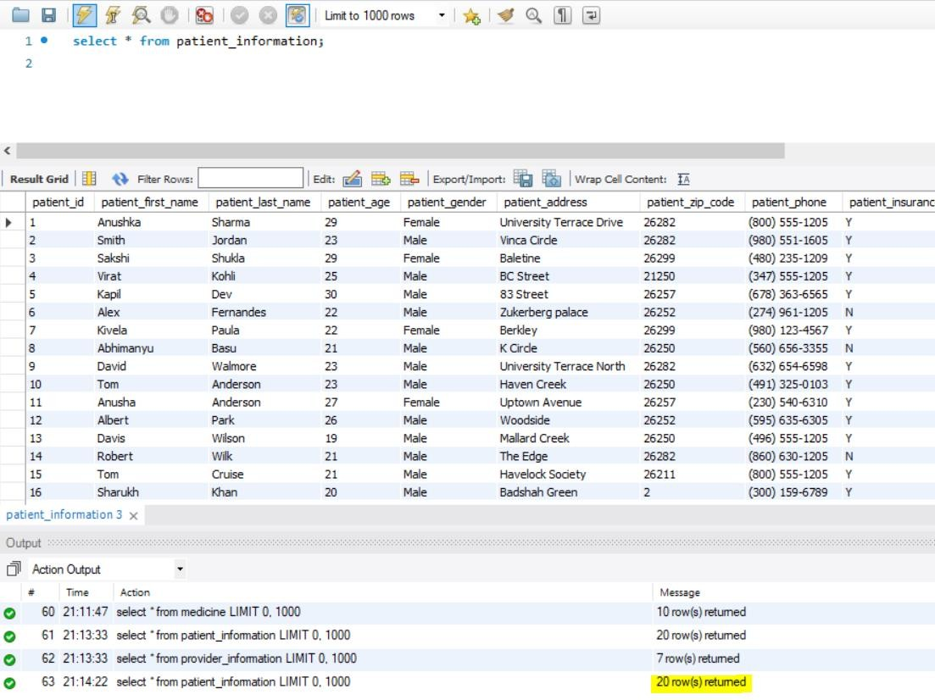

1. select * from zip_code;

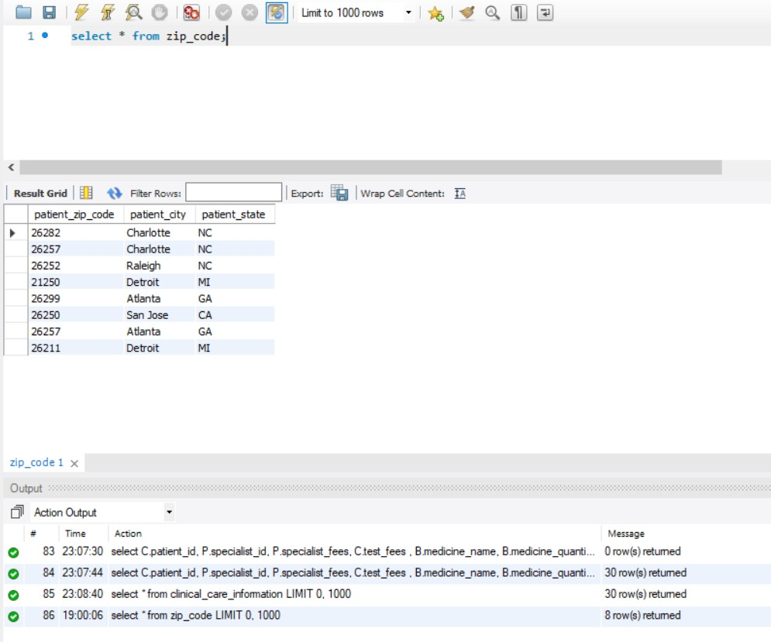

1. select * from provider_information;

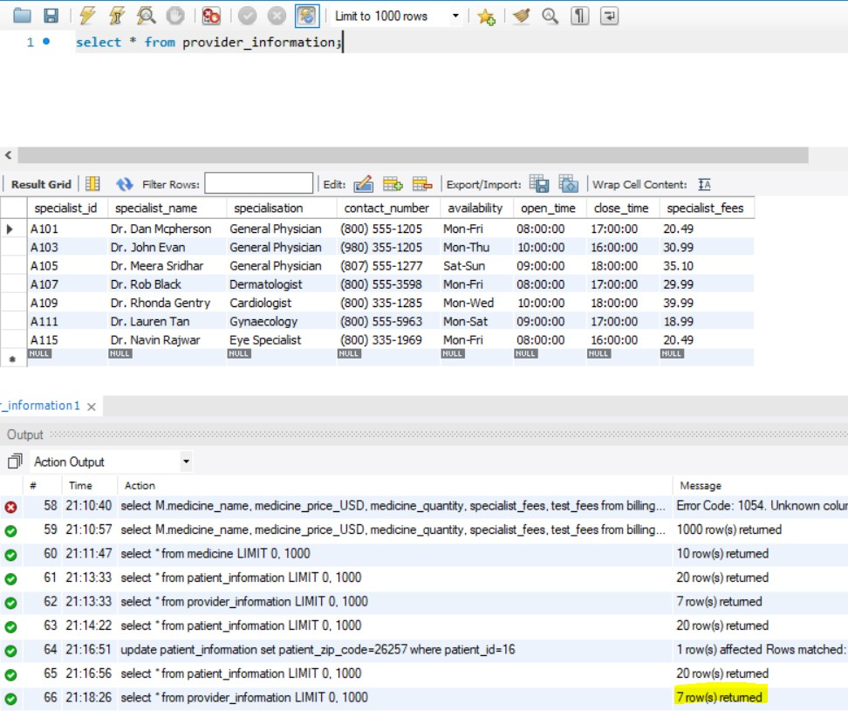

1. select * from visit_information;

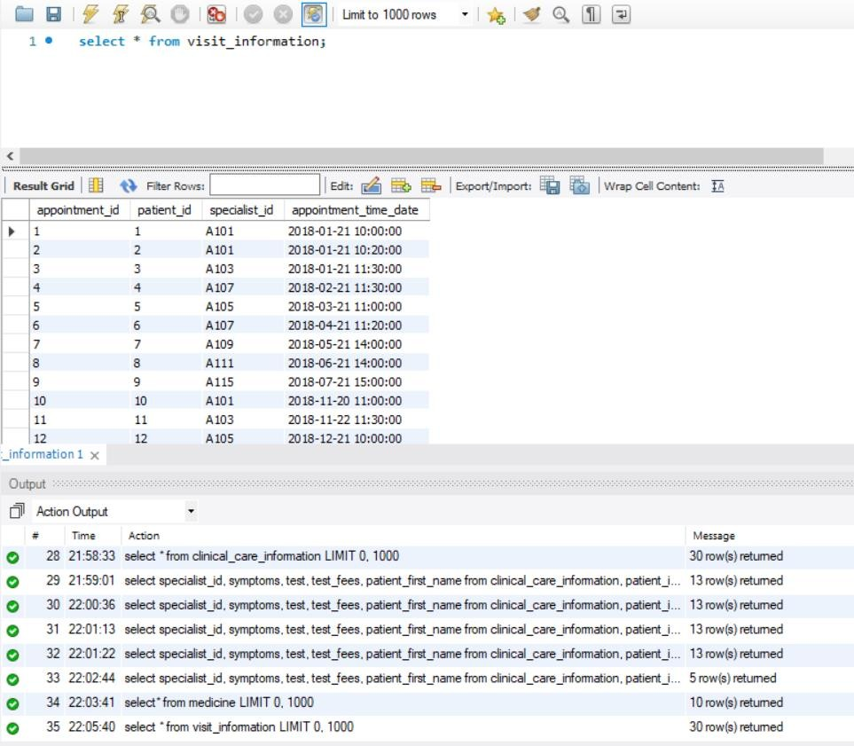

1. select * from clinical_care_information;

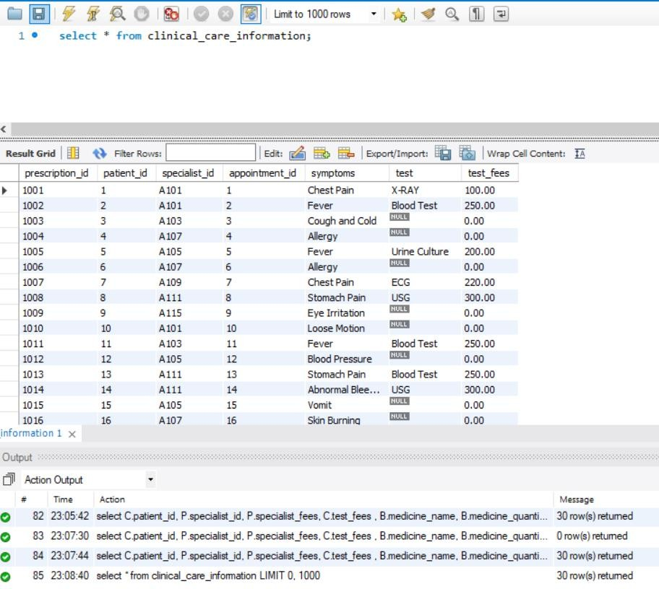

1. select * from billing;

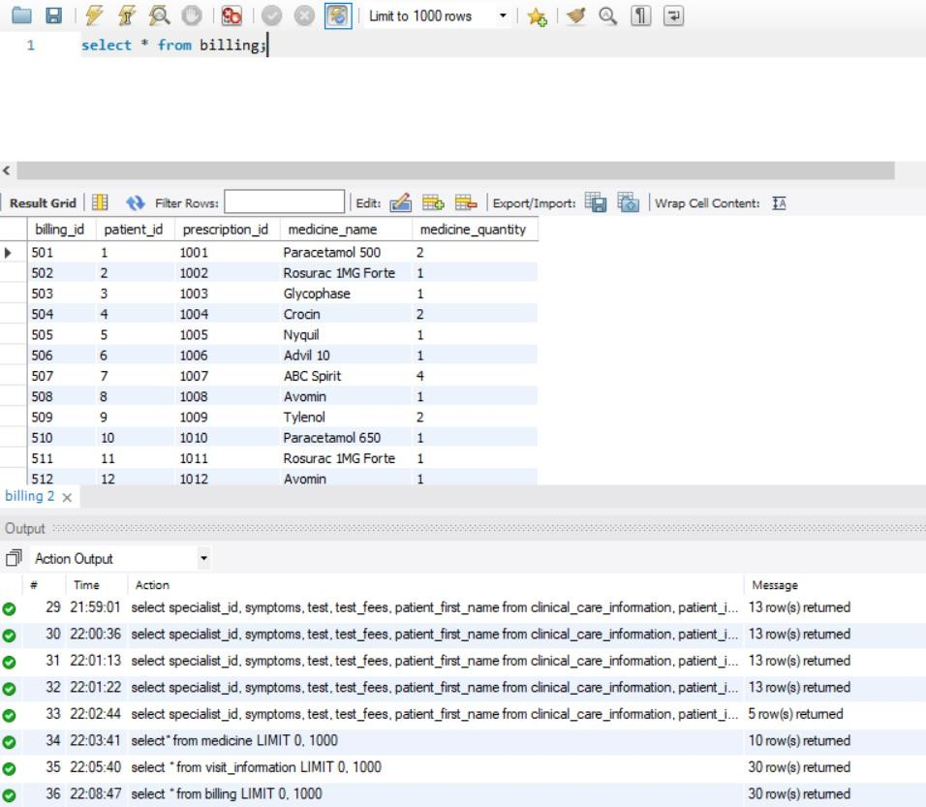

1. 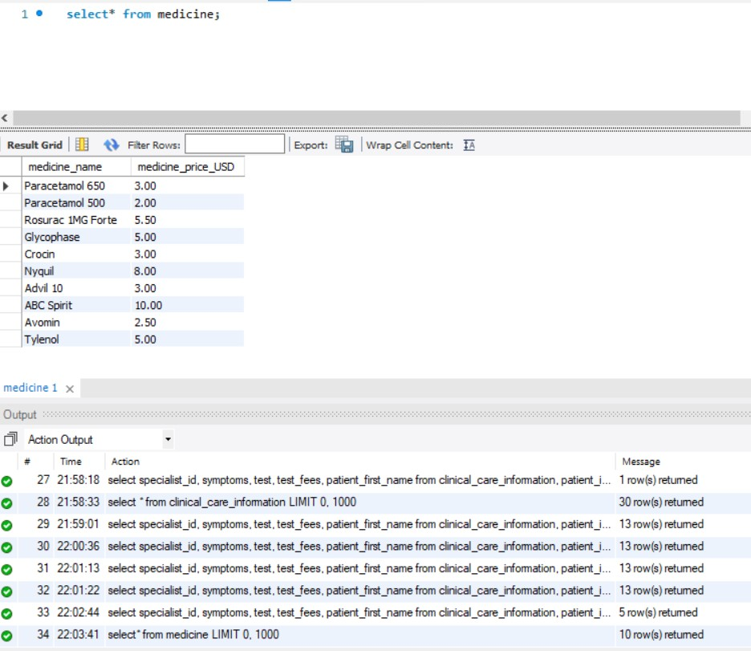select * from medicine;

# SQL Operations and Screenshots

Insert Operation:

*Insert a new entry into the zip_code table.*

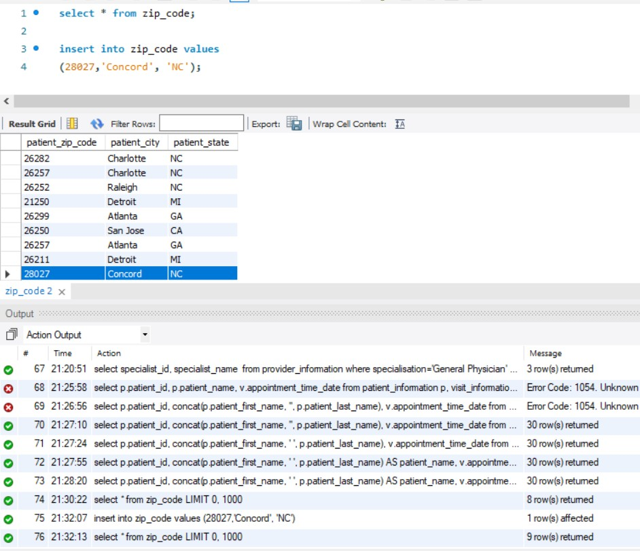insert into zip_code values (28027, ’Concord’, ’NC’)

Delete Operation:

*Delete the new entry from the zip_code table.*

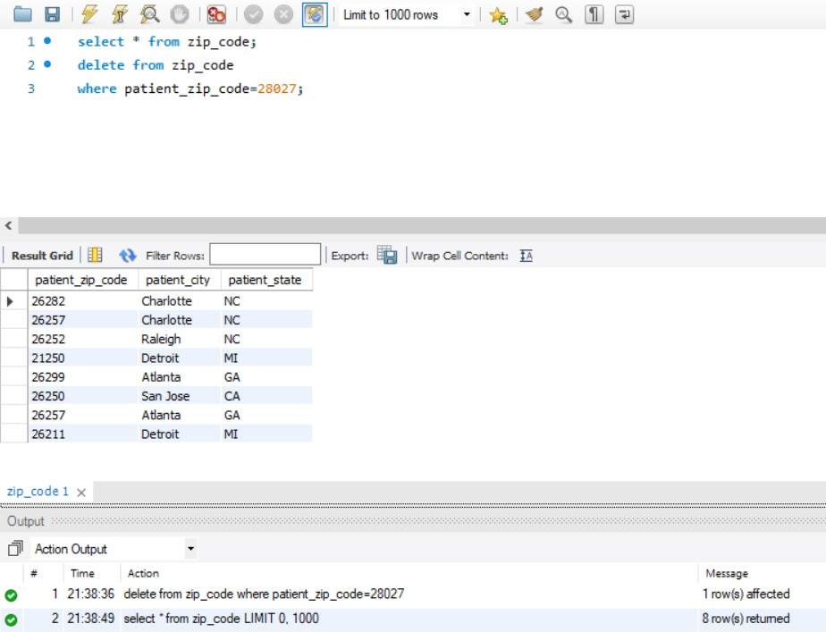delete from zip_code

where patient_zip_code=28027;

Update Operation:

*Update zip code to 26257 for the patient id 16.*

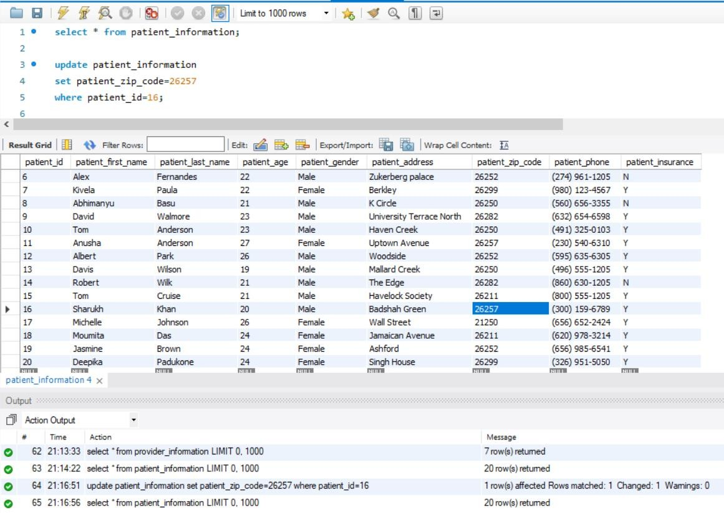update patient_information set patient_zip_code=26257 where patient_id=16;

Search Operation:

*Search specialist id and name of all the general physicians.*

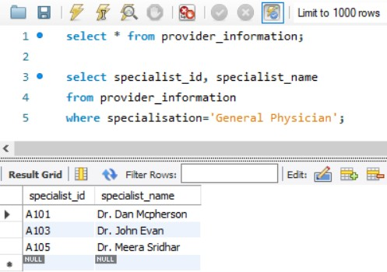select specialist_id, specialist_name from provider_information

where specialisation='General Physician';

Alias, Concat function and Order By clause:

*Show patient id, patient’s full name and the appointment time_date for all the patients and sort them in descending order of appointment time_date.*

select p.patient_id, concat(p.patient_first_name, ' ', p.patient_last_name) AS patient_name, v.appointment_time_date

from patient_information p, visit_information v where p.patient_id=v.patient_id

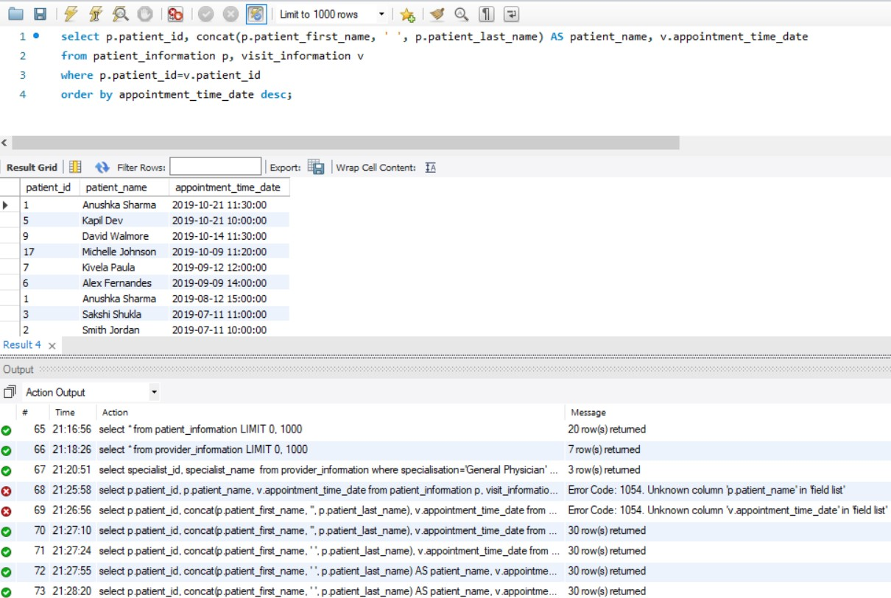order by appointment_time_date desc;

Subquery, Aggregation and Group By clause

*Show patient id, specialist id and number of visits for the patients whose age is more than 23.*

select patient_id, specialist_id, count(patient_id) as visit from visit_information where patient_id in

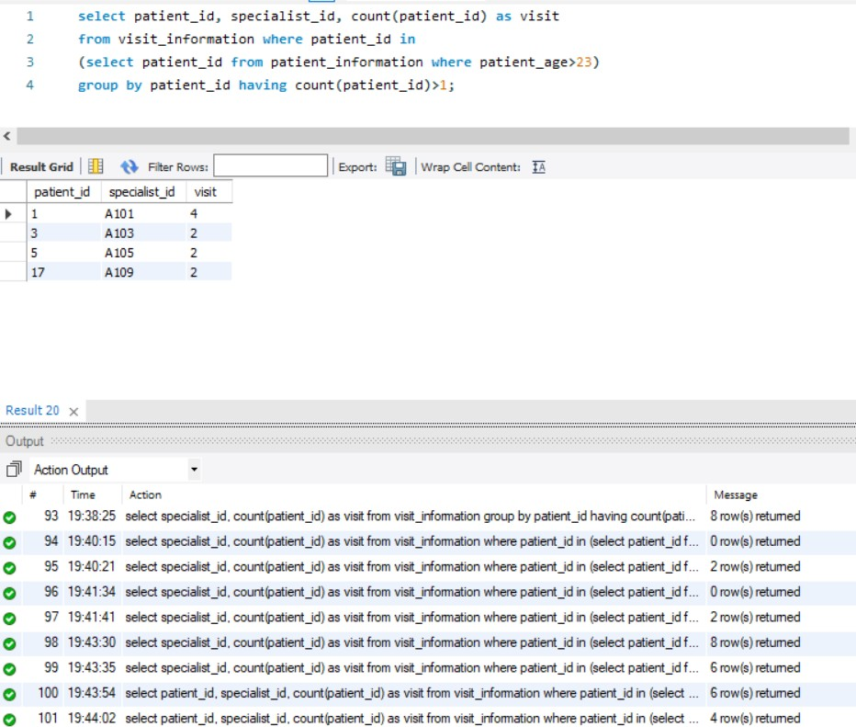(select patient_id from patient_information where patient_age>23) group by patient_id having count(patient_id)>1;

Join using comma (,) and Where clause

*Show specialist id, symptoms, test, test fees and patient first name for those patients who visited the clinic only for Chest pain.*

select specialist_id, symptoms, test, test_fees, patient_first_name from clinical_care_information, patient_information

where clinical_care_information.patient_id = patient_information.patient_id and symptoms='Chest Pain';

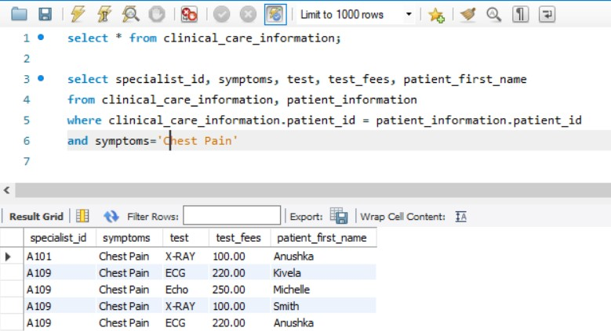

Join more than two tables using On clause

*Show patient id, specialist id, specialist fees, test fees, medicine name, medicine quantity, medicine price and total billing amount charged by the clinic for all the patients and sort them in ascending order of patient id.*

select C.patient_id, P.specialist_id, P.specialist_fees, C.test_fees , B.medicine_name, B.medicine_quantity, M.medicine_price_USD,

(C.test_fees+P.specialist_fees+M.medicine_price_USD*B.medicine_quantity) AS 'Total Billing Amount' from provider_information P join clinical_care_information C on C.specialist_id = P.specialist_id

join billing B on C.prescription_id=B.prescription_id

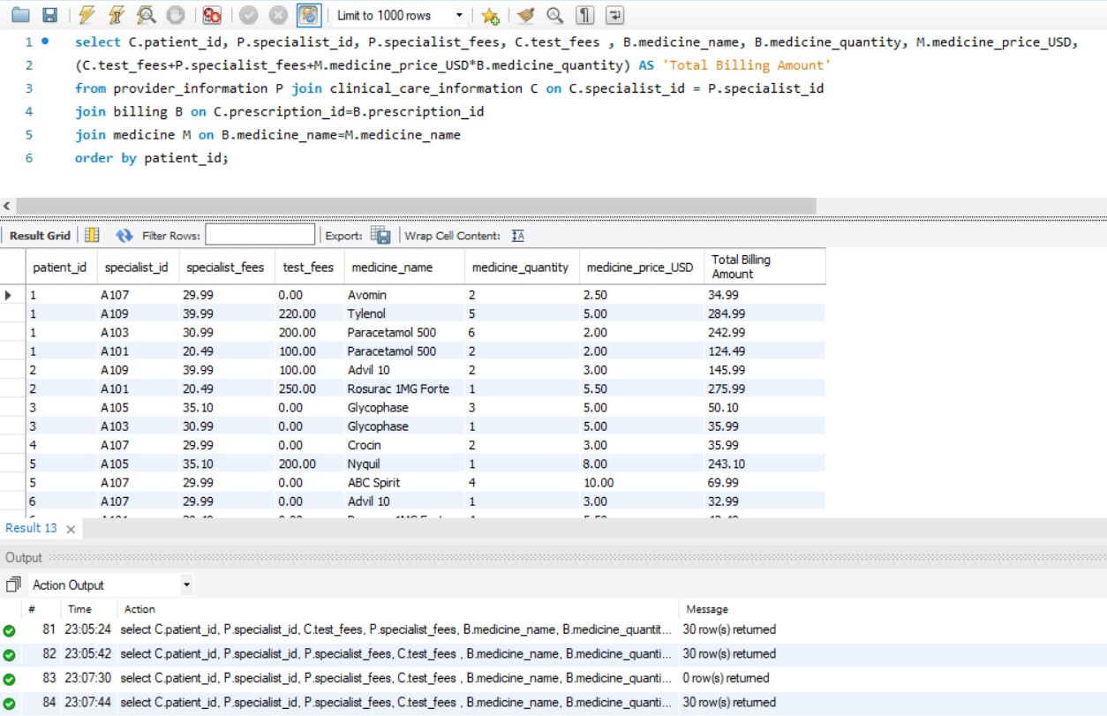join medicine M on B.medicine_name=M.medicine_name order by patient_id;

# ER Diagram

An Entity Relationship Diagram (ERD) is a snapshot of data structures. An Entity Relationship Diagram shows entities (tables) in a database and relationships between tables within that database. Below is the snapshot of the database smr_db5

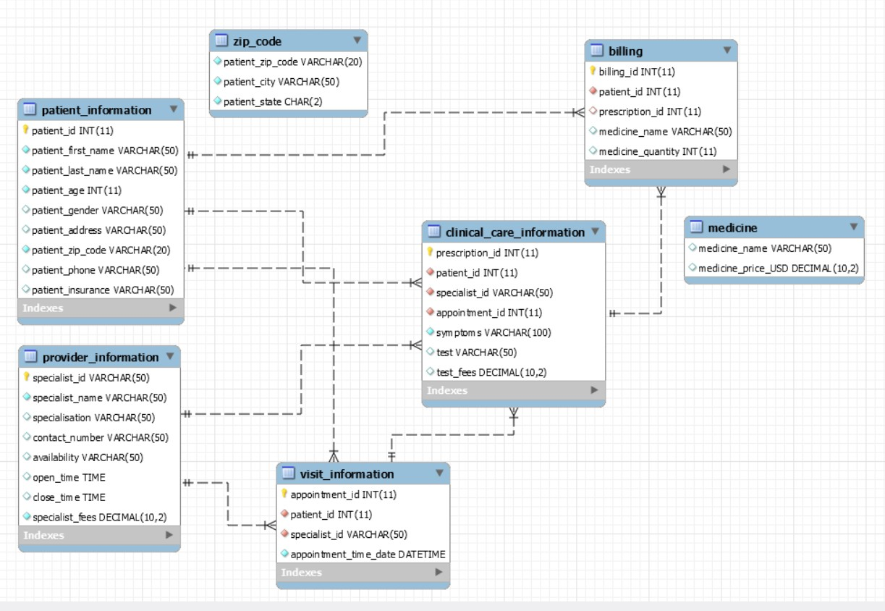

# UML Diagram

A UML diagram is a diagram based on the Unified Modeling Language with the purpose of visually representing a system along with its main actors, roles, actions, artifacts or classes, in order to better understand, alter, maintain, or document information about the system

